|  |  |  |  |  |  |
| --- | --- | --- | --- | --- | --- |
| Date | Sept 20, 2022 | | | Tester Name | Alyssa Johnson |
| Environment | Penfax - Test | | | Login used |  |
| Operating System | Select OS | Version: | Update: | | |
| Software Used | Select Software | Version: | Update: | | |
| Select Software | Version: | Update: | | |
| Release version | 22.3.0 | | | | |
| Title | E23.08 | | | | |
| Test Type | Regression | | | | |
| Test Scenario | VPB Welcome Letters | | | | |
|  |  | | | | |
| Expected Results | Verify the batch run successfully and letters generated and saved on member communications and visible on PLANet member  Note, have members for each of these scenarios:  - PEPP to VPB  - DC SRB - VPB to VPB (ex-spouse)  - Old member coming back to VPB (no previous VPB account)  - Death payment to VPB (spouse)  - VPB with no DAI  - VPB set up with no minimum age selection  - VPB set up with scheduled payment & specified order | | | | |
| Pass/Fail | Pass | | | JIRA# | N/A |

VPB Welcome letters (checked the following scenarios/members):

|  |  |  |  |
| --- | --- | --- | --- |
| Stakeholder | Type | Search criteria | Outcome |
| 308374 | PEPP to VPB | Deferred & over 50 years |  |
| 307340 | PEPP partial (5k) to VPB  -included trustee beneficiary | Deferred & over 50 years |  |
| 295094 | VPB no min age entered | Deferred & over 50 |  |
| 250370 | VPB to VPB DC SRB | Married & VPB active |  |
| 298850 | Old MBR coming back to VPB | Retired, no funds left in PEPP or VPB (was not previously in VPB) |  |
| 311536 | PEPP to VPB, beneficiaries missing | Deferred and over 50 |  |
| 300998 | VPB set up, DAI missing | Deferred and over 50 |  |

Processed above scenario’s (Sept 20, 2022)

298850 – Non-member coming back to VPB

Screen shots to show new VPB account creation & deposit.

Note: Make sure that the correct VPB membership period is selected in the deposit or the funds will go into PEPP.

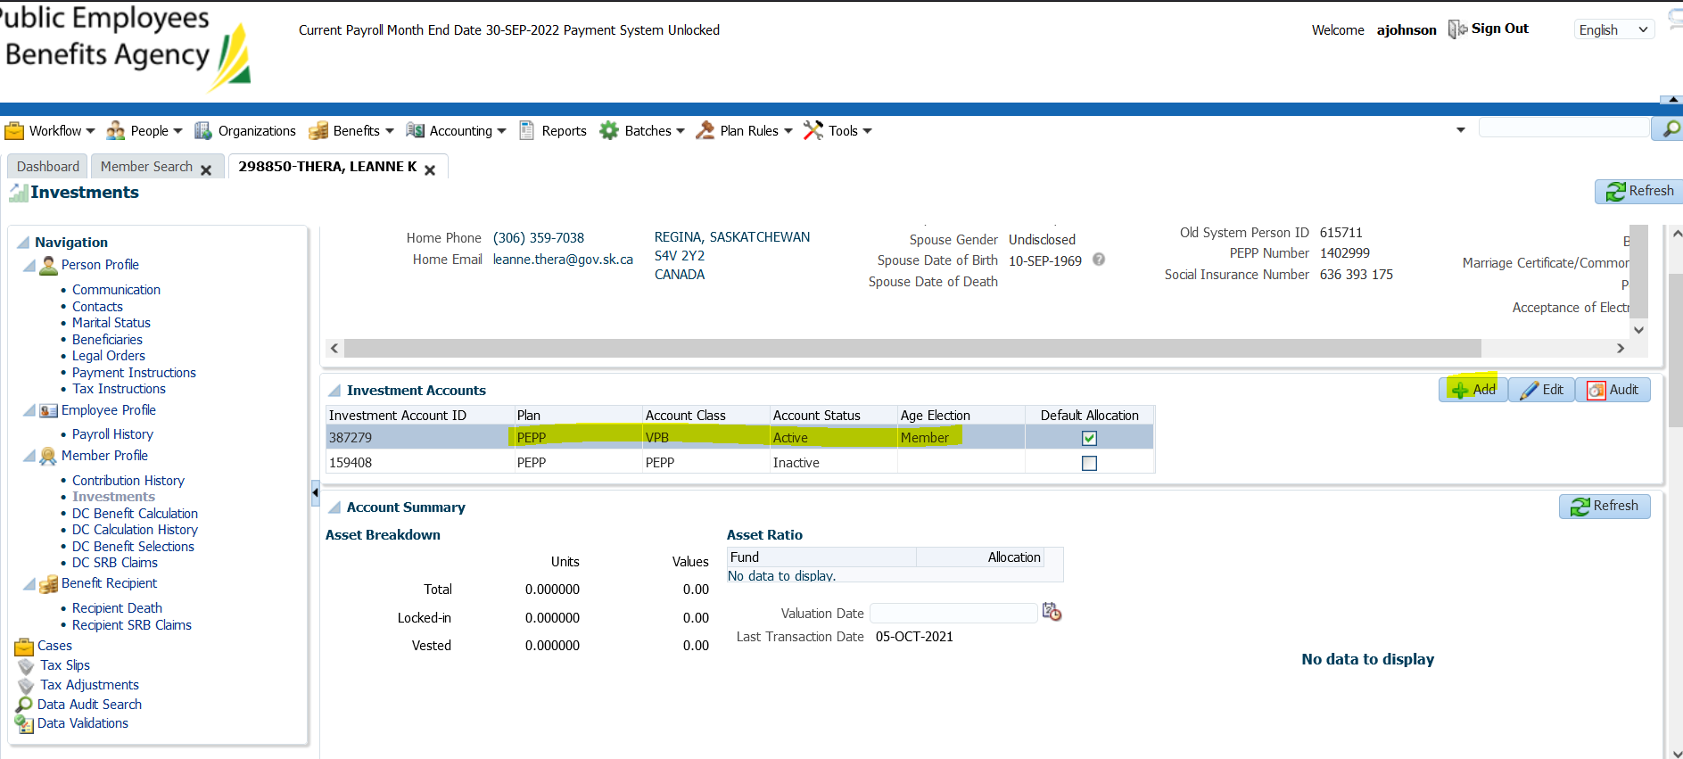

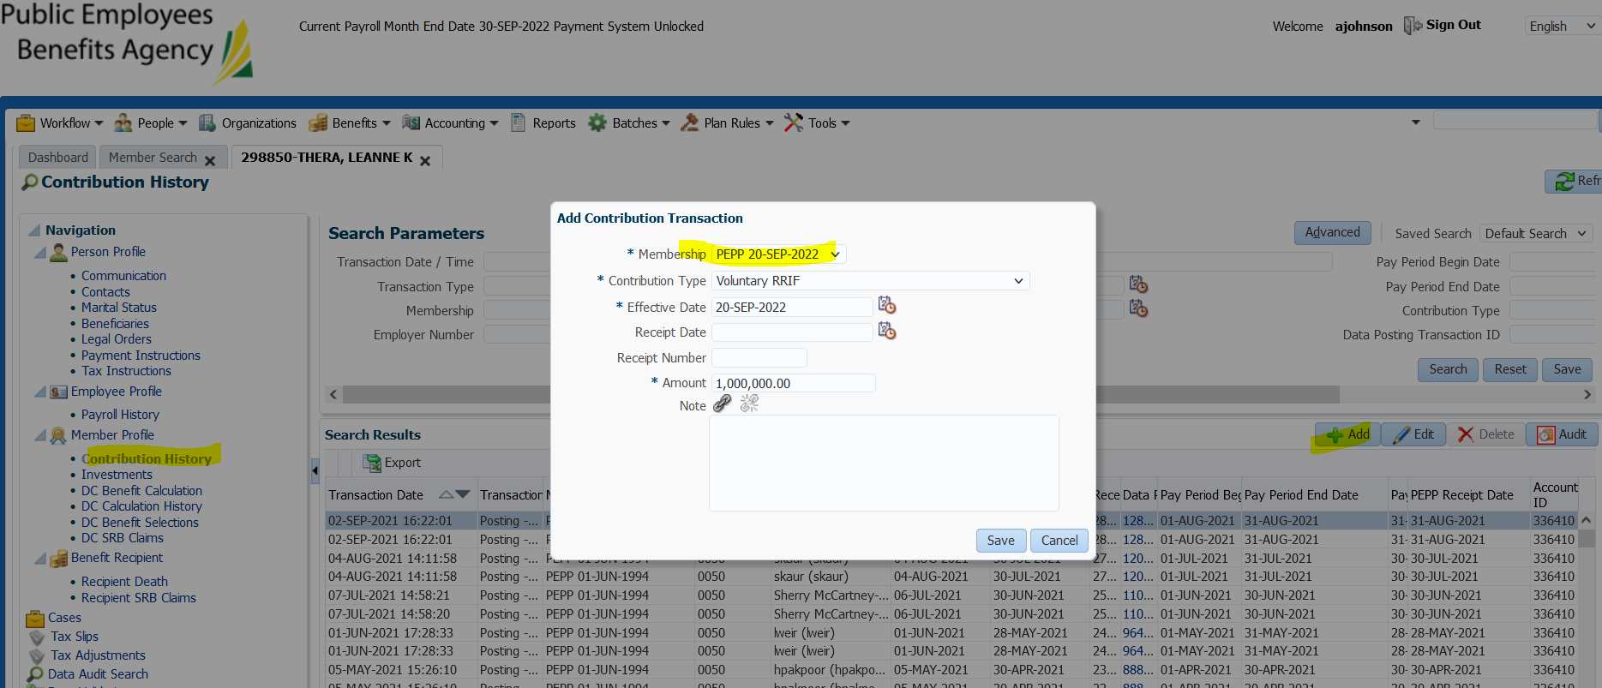

Expected Result overnight, s/b atleast 7 VPB welcome letters – 1 for each member. And that they show on communications tab and PlaNet.

Letters all show up on daily letter report:

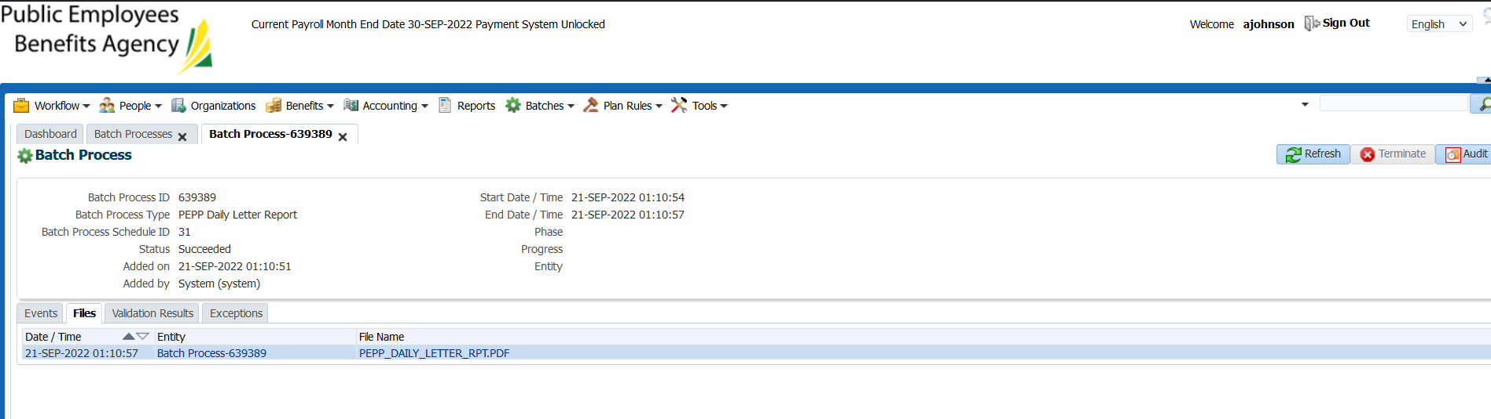

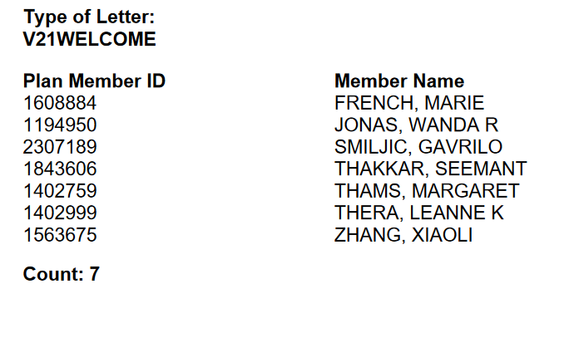

SID 298850 – shows correctly under outbound documents & member documents online.

